|  |
| --- |
| J.Earles – C.O’Hara – G.Smith – C.Vatter |

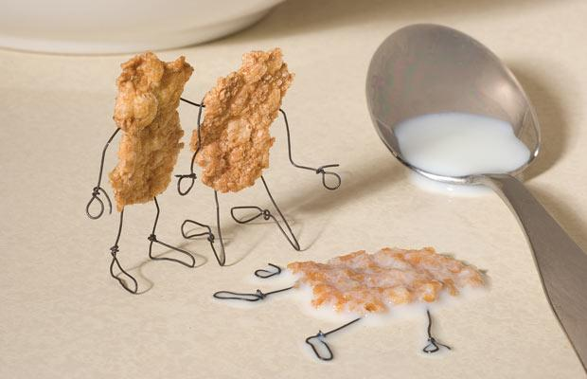

|  |  |
| --- | --- |
| Rose-Hulman Institute of Technology |  |

**CSSE333-02**

**Serial Killer DB**

Table of Contents

1. Executive Summary 2

2. Introduction 2

3. High Level Problem Summary 2

3.1 Elevator Statement 2

3.2 Primary Success Criteria 2

3.3 Scope 2

3.3.1 Within Scope 2

3.3.2 Outside Scope 3

4. Detailed Problem Statement 3

4.1 Function 3

4.2 Form 3

4.2.1 Availability 3

4.2.2 Usability 3

4.2.3 Performance 4

4.2.4 Security 4

4.2.5 Maintainability 4

4.3 Economy 4

4.3.1 Marketability 4

4.4 Time 4

4.4.1 Historical 4

4.4.2 Current 4

4.4.3 Future 4

5. Key Stakeholders 5

6. References 5

7. Glossary 5

|  |  |  |
| --- | --- | --- |
| **Version** | **Date** | **Comments** |
| 1.0 | 1/16/14 | Initial Draft |
|  |  |  |

# Executive Summary

This document is meant to describe the problem that our project will solve in a thorough detail. The Entity Relationship Diagram has been designed and joined with this document as well – prior to elaborating on our potential database design, the problem will be summarized at a high level, then detailed, and we will briefly cover some information about our possible stakeholders.

We’ve chosen to investigate a problem in the world that most people tend not to acknowledge, and many people fear, but yet there is so much to learn about the human condition from it. On occasion people grow up under certain conditions and are affected by the events around them in such a way that they grow an insatiable bloodlust for other humans. Other cases can simply be psychological issues that developed and grew rampantly in an individual’s mind – this database is intended to document the Serial Killer.

# Introduction

For our database we will be focusing on in depth details surrounding modern, recent, and historic serial killers - the purpose of this database we create is to educate people on the backgrounds of serial killers and the factors that lead them to kill. It can also be used to develop useful patterns to determine what types of experiences, medical conditions, and environments are most likely to breed a serial killer and prevent such people from committing these acts. On a more leisurely perspective, this database can be a place for people who are interested in crime investigation and serial killer history to go to find out more.

# High Level Problem Summary

## Elevator Statement

We are building a database to track the history and patterns of serial killers. There is currently no effective web-based database for serial killer information used for public educational purposes. We propose to provide this online educational resource on serial killers for the general public.

## Primary Success Criteria

Our primary goal is to provide serial killer data to interested individuals, and to provide a means of observing patterns in serial killings. Many serial killings have similarities, and noticing these similarities can help society become more knowledgeable about this topic and help prevent future serial killings. In addition, this project gives individuals a way to research and learn about the history of serial killing.

## Scope

### Within Scope

1. Serial Killers
2. Victims
3. Locations
4. Police Records
5. Dates

### Outside Scope

1. Parental and hereditary information
2. Non-murdering criminals
3. Non-famous one-time murderers

# Detailed Problem Statement

## Function

1. Ability to browse through numerous serial killers by:
   1. Name
   2. Date
   3. Number of Victims
   4. Type of killer
   5. Disorder
   6. Motive
2. Ability to browse through victims by:
   1. Name
   2. Date of death
   3. Location of murder
3. Ability to browse through police records by:
   1. Department/Agency
   2. Case End
   3. Serial Killer
4. Ability to browse locations by:
   1. City
   2. State/Province

## Form

### Availability

* Accessible via a website for research purposes.

### Usability

* Fast response and lookup times.
* Intuitive interface
* Guaranteed compatible with all major browsers excluding Internet Explorer
* Website content will be update on a regular time interval no longer than every 24 hours.

### Performance

* Over 90% uptime
* Can support up to, but no more than, 100 users

### Security

* Restricted access to the main database and web server will be implemented.
* All info displayed on the site will be public and non-restricted.

### Maintainability

* Members of the development team will have the ability to access the website and database for maintenance.
* Software should contain error correcting code in order to cut down on human maintenance.

## Economy

### Marketability

There is no central website whose sole purpose is to provide information about serial killers. This project will allow users to research serial killers and will provide an easy-to-use interface to search for information.

## Time

### Historical

Prior to computers, serial killer data was stored in files all over the country, with no central database or collection location. With computer technology, databases have been created to store serial killer information, both for criminal investigation/justice and educational use.

### Current

Currently, there is no website whose primary purpose is to provide serial killer information to users. There are databases on other sites, such as the FBI’s site, but the site’s purpose isn’t just to provide serial killer data. This project will provide users a central location to search for serial killers and to learn more about this serious topic.

### Future

In the future, more features will be implemented in order to provide users more search options. In addition, more data will be stored so as to provide users with as much information as possible. Not only will this make users more knowledgeable and have a better experience, it will also allow researchers to discover more patterns and influences behind serial killers’ motives, and ultimately prevent future tragic events.

# Key Stakeholders

|  |  |
| --- | --- |
| **Name** | **Role** |
| **Greg Wilkins** | **Project Advisor** |
| **Jonathan Earles** | **Project Team** |
| **Corey Vatter** | **Project Team** |
| **Grant Smith** | **Project Team** |
| **Christopher O’Hara** | **Project Team** |
| **Serial Killer Researchers** | **End Users** |

# References

Lane, Brian, and Wilfred Gregg. “The Encyclopedia of Serial Killers.” New York City: Berkley Books, 1995. Print.

# Glossary

Serial killer – Traditionally a person who has killed two or more people in over a month; usually with a pattern of operation.

Internet Explorer – Made my Microsoft, considered one of the worst browsers to exist in human history

Greg Wilkin – A rad rock n’ roller turned pretty cool professor at Rose-Hulman Institute of Technology. He currently models his life after an electron, living in two places at once.